LMS Online Quiz –

Export/ Import Questions in Question Bank

Export Questions

After creation of questions in the main category of the question bank or in its sub-categories, the questions can be exported from the Quiz module and the Question bank in any one of 4 formats:

- Aiken format
- GIFT format
- Moodle XML format
- XHTML format

- Click on the “Export” tab on the question bank page.
- Choose any of the file formats.
- Select the category you want to export to a file and click the “Export questions to file” button.
- After exporting the questions/ question bank from one course, exactly the same format has to be chosen to import the exported file into the question bank of any other LMS course.
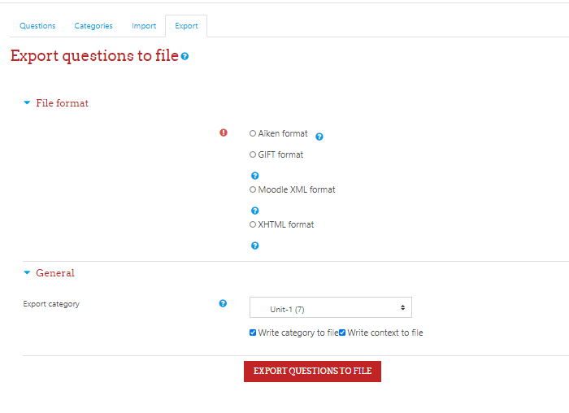
Note: Images are only included if you export the questions using “Moodle XML format”. It is highly recommended to export Moodle XML file which can then be imported in another LMS course without loss of any information.

Import Questions

Moodle has a number of different formats that can be used to import questions into Question bank categories. These include some proprietary quiz software formats, as well as text files and Moodle formats.
Click on the “Import” tab on the question bank page.

1. Aiken format:
The Aiken format is a very simple way of creating multiple choice questions using a clear human-readable format in a text file. (The GIFT format has many more options but doesn't look as straight-forward as AIKEN.) The question must be all on one line. Each answer must start with a single uppercase letter, followed by a period '.' or a bracket ')', then a space. The answer line must immediately follow, starting with "ANSWER: " (NOTE the space after the colon) and then giving the appropriate letter.

IMPORTANT NOTES:
- You have to save the file in a text format. Don't save it as a Word document or anything like that.
- Non-ASCII characters like 'quotes' can cause import errors. To avoid this always save your text file in UTF-8 format (most text editors, even Word, will ask you).
- The answer letters (A,B,C etc.) and the word "ANSWER" must be capitalised as shown below, otherwise the import will fail.
Here is an example of the format:

What is the correct answer to this question?
A. Is it this one?
B. Maybe this answer?
C. Possibly this one?
D. Must be this one!
ANSWER: D

Which LMS has the most quiz import formats?
A) Moodle
B) ATutor
C) Claroline
D) Blackboard
E) WebCT
F) Ilias
ANSWER: A

2. GIFT format:
GIFT format allows someone to use a text editor to write multiple-choice, true-false, short answer, matching missing word and numerical questions in a simple format that can be imported.
The GIFT format is also an export file format available in Question bank. When creating a large number of questions, GIFT can provide a quick way of bulk loading questions.

General instructions
At least one blank line must be left between each question.

In the simple form, the question comes first, then the answers are set in between brackets, with an equal sign (=) indicating the correct answer(s) and tilde (~) the wrong answers. A hash (#) will insert a response. Questions can be weighted by placing percentage signs (%..%) around the weight. Comments are preceded by double slashes (//) and are not imported.

Format symbols
Here are some common GIFT symbols and their use.
Symbols | Use
// text | Comment until end of line (optional)
::title:: | Question title (optional)
text | Question text (becomes title if no title specified)
[...format...] | The format of the following bit of text. Options are [html], [moodle], [plain] and [markdown]. The default is [moodle] for the question text, other parts of the question default to the format used for the question text.
{ | Start answer(s) -- without any answers, text is a description of following questions
{T} or {F} | True or False answer; also {TRUE} and {FALSE}
{ ... =right ... } | Correct answer for multiple choice, (multiple answer? -- see page comments) or fill-in-the-blank
{ ... ~wrong ... } | Incorrect answer for multiple choice or multiple answer
{ ... =item -> match ... } | Answer for matching questions
#feedback text | Answer feedback for preceding multiple, fill-in-the-blank, or numeric answers
####general feedback | General feedback
{# | Start numeric answer(s)
answer:tolerance | Numeric answer accepted within ± tolerance range
low..high | Lower and upper range values of accepted numeric answer
=%n%answer:tolerance | n percent credit for one of multiple numeric ranges within tolerance from answer
} | End answer(s)
\character | Backslash escapes the special meaning of ~, =, #, {, }, and :
\n | Places a newline in question text -- blank lines delimit questions
Here are some quick examples:
// true/false
::Q1:: 1+1=2 {T}

// multiple choice with specified feedback for right and wrong answers
::Q2:: What's between orange and green in the spectrum?
{ =yellow # right; good! ~red # wrong, it's yellow ~blue # wrong, it's yellow }

// fill-in-the-blank
::Q3:: Two plus {=two =2} equals four.

// matching
::Q4:: Which animal eats which food? { =cat -> cat food =dog -> dog food }

// math range question
::Q5:: What is a number from 1 to 5? {#3:2}

// math range specified with interval end points
::Q6:: What is a number from 1 to 5? {#1..5}
// translated on import to the same as Q5, but unavailable from Moodle question interface

// multiple numeric answers with partial credit and feedback
::Q7:: When was Ulysses S. Grant born? {#
=1822:0 # Correct! Full credit.
=%50%1822:2 # He was born in 1822. Half credit for being close.
}

// essay
::Q8:: How are you? {}

Reference: https://docs.moodle.org/310/en/GIFT_format

Question format examples - GIFT
There are several ways to use a text editor to write a GIFT format.

Multiple choice
For multiple choice questions, wrong answers are prefixed with a tilde (~) and the correct answer is prefixed with an equal sign (=).
Here is a simple acceptable GIFT multiple choice format:
Who's buried in Grant's tomb?{=Grant ~no one ~Napoleon ~Churchill ~Mother Teresa }
Here is a longer format that uses most of the GIFT elements:
// question: 1 name: Grants tomb
::Grants tomb::Who is buried in Grant's tomb in New York City? {
=Grant
~No one
#Was true for 12 years, but Grant's remains were buried in the tomb in 1897
~Napoleon
#He was buried in France
~Churchill
#He was buried in England
~Mother Teresa
#She was buried in India
}

Multiple choice with multiple right answers
That is, using checkboxes, not radio buttons:
What two people are entombed in Grant's tomb? {
~%-100%No one
~%50%Grant
~%50%Grant's wife
~%-100%Grant's father
}

True-false
In this question-type the answer indicates whether the statement is true or false. The answer should be written as {TRUE} or {FALSE}, or abbreviated to {T} or {F}.
// question: 0 name: TrueStatement using {T} style
::TrueStatement about Grant::Grant was buried in a tomb in New York City.{T}
// question: 0 name: FalseStatement using {FALSE} style
::FalseStatement about sun::The sun rises in the West.{FALSE}

Short answer
Answers in Short Answer question-type are all prefixed by an equal sign (=), indicating that they are all correct answers. The answers must not contain a tilde.
Here are two examples using the simple method showing possible right answers for credit.
Who's buried in Grant's tomb?{=Grant =Ulysses S. Grant =Ulysses Grant}
Two plus two equals {=four =4}
If there is only one correct Short Answer, it may be written without the equal sign prefix, as long as it cannot be confused as True-False.

Matching
Matching pairs begin with an equal sign (=) and are separated by this symbol "->". There must be at least three matching pairs.
Match the following countries with their corresponding capitals. {
=Canada -> Ottawa
=Italy -> Rome
=Japan -> Tokyo
=India -> New Delhi
}
Matching questions do not support feedback or percentage answer weights.

Missing word
The Missing Word format automatically inserts a fill-in-the-blank line (like this _____) in the middle of the sentence. To use the Missing Word format, place the answers where you want the line to appear in the sentence.
Moodle costs {~lots of money =nothing ~a small amount} to download from moodle.org.

If the answers come before the closing punctuation mark, a fill-in-the-blank line will be inserted for the "missing word" format. All question types can be written in the Missing Word format.
There must be a blank line (double carriage return) separating questions. For clarity, the answers can be written on separate lines and even indented. Some examples:
Mahatma Gandhi's birthday is an Indian holiday on {
~15th
~3rd
=2nd
} of October.

Since {
~495 AD
=1066 AD
~1215 AD
~ 43 AD
}
the town of Hastings England has been "famous with visitors".

Numerical questions
The answer section for Numerical questions must start with a number sign (#). Numerical answers can include an error margin, which is written following the correct answer, separated by a colon. So for example, if the correct answer is anything between 1.5 and 2.5, then it would be written as follows {#2:0.5}. This indicates that 2 with an error margin of 0.5 is correct (i.e., the span from 1.5 to 2.5). If no error margin is specified, it will be assumed to be zero.
Here is a simple numerical format question. It will accept a range of 5 years.
When was Ulysses S. Grant born?{#1822:5}

It is a good idea to check the margins of the range, 3.141 is not counted as correct and 3.142 is considered in the range.
What is the value of pi (to 3 decimal places)? {#3.14159:0.0005}.

Optionally, numerical answers can be written as a span in the following format {#MinimumValue..MaximumValue}.
What is the value of pi (to 3 decimal places)? {#3.141..3.142}.

Essay
An essay question is simply a question with an empty answer field. Nothing is permitted between the curly braces at all.
Write a short biography of Dag Hammarskjöld. {}

Description
A description "question" has no answer part at all
You can use your pencil and paper for these next math questions.

3. Moodle XML format

The XML format is Moodle-specific format for importing and exporting questions to be used with the Quiz module.

* It is recommended to choose Moodle XML format to export already created questions from the question bank, which can then be imported in another LMS course using the same XML format import.

______________________

